Hostel Management System
Aman Kumar Priyanshu kumar
23BCS11038 23BCS11649
Abstract
The Hostel Management System is a comprehensive and dynamic web-based application designed to streamline and automate the management of hostel operations. It primarily focuses on simplifying administrative tasks such as student registration, room allocation, record maintenance, and complaint handling. Built using Java Spring Boot as the backend framework and MySQL as the database, the system provides a robust, scalable, and user-friendly platform for managing student accommodations in educational institutions and residential complexes.
This project eliminates the inefficiencies of traditional paper-based record-keeping and manual data entry by introducing a digitized, centralized, and automated management system. The application offers separate interfaces for administrators, wardens, and students, each tailored to their roles and responsibilities within the hostel environment. Key functionalities include student registration, room management, booking allocation, and complaint tracking, ensuring an efficient, transparent, and secure workflow for all users.
From a technical standpoint, the system leverages the Spring Boot framework to build a modular and maintainable backend architecture. It uses Spring Data JPA (Hibernate) for data persistence, simplifying interactions with the MySQL relational database. The adoption of a three-tier architecture — comprising the presentation layer, business logic layer, and data access layer — ensures high scalability, modularity, and reusability of components.
The Student Module allows new users to register with their personal and academic details, securely stored in the database. The Room Management Module empowers administrators to add, edit, or remove room records, categorize rooms based on capacity and type, and monitor occupancy in real time. The Booking Module automates the room allocation process by validating availability and preventing double bookings, thereby optimizing space utilization. The Complaint Management Module enables students to register grievances or maintenance requests, which can then be tracked and managed by administrators or maintenance personnel.
Security is implemented through Role-Based Access Control (RBAC), ensuring that only authorized users can access specific functionalities. Administrators have full access to the system, while students and wardens have limited permissions based on their responsibilities. Additional technologies such as Docker can be integrated for containerization, enhancing portability and simplifying deployment across multiple environments.
The project aims to reduce administrative workload, enhance data accuracy, and improve service efficiency within hostel management. It also promotes environmental sustainability by reducing paper usage and supporting digital documentation. With future enhancements such as online payment integration, automated notifications, and analytics dashboards, this system can be extended into a comprehensive, enterprise-grade hostel management platform.
In summary, the Hostel Management System represents a step toward digital transformation in hostel administration. It provides an integrated, transparent, and reliable solution for both students and staff, enabling smooth coordination, efficient operations, and improved overall user satisfaction.

Introduction
Managing a hostel manually often involves repetitive administrative tasks such as maintaining records of students, tracking room occupancy, handling complaints, and managing payments. These processes can be time-consuming, error-prone, and inefficient when handled through paper-based systems or spreadsheets. To overcome these challenges, the Hostel Management System introduces an automated approach that integrates all hostel management operations into a single, cohesive digital platform.
The system is developed using Java Spring Boot, a powerful framework that simplifies backend development through dependency injection, RESTful APIs, and modular project structure. The backend communicates with a MySQL database for persistent data storage and retrieval. This structure enables seamless management of large volumes of data while maintaining high performance and reliability.
This project aims to provide a complete automation solution for hostel operations, ensuring that administrators can easily manage room allocations, monitor availability, and respond to complaints. It also enhances student convenience by providing an online interface for registration, room booking, and complaint submission.
Objectives of the Project
- To automate hostel administrative processes and reduce manual workload.
- To ensure accuracy and consistency in data management.
- To provide a transparent and user-friendly interface for students and staff.
- To improve response time in handling maintenance requests and complaints.
- To centralize hostel data for easy access, reporting, and future analysis.
- To enhance system security through authentication and access control mechanisms.
Overall, the Hostel Management System aims to enhance efficiency, reduce paperwork, and create a more organized and reliable environment for hostel management operations.

Tools & Technologies
The development of this system incorporates modern technologies that ensure performance, scalability, and maintainability.
Languages & Frameworks
- Java (JDK 17+): Core programming language used for backend logic.
- Spring Boot Framework: Provides the backbone for RESTful services, dependency injection, and application management.
- Spring Data JPA (Hibernate): Facilitates interaction with the database by simplifying CRUD operations and ensuring consistent data persistence.
- Spring Security (Optional): Used for implementing user authentication and role-based authorization.
Database
- MySQL 8+: Used as the relational database management system to store structured data such as student details, room information, bookings, and complaints.
- Hibernate ORM ensures seamless mapping between Java entities and database tables.
Build Tool
- Maven: Used for project build automation, dependency management, and configuration control.
Integrated Development Environment (IDE)
- IntelliJ IDEA or Visual Studio Code: Used for coding, debugging, and project execution.
Other Tools
- Postman: For API testing and validation of backend endpoints.
- Docker (optional): For containerizing the application, enabling smooth deployment on multiple platforms.
- Git & GitHub: For version control and collaborative development.

System Analysis
System analysis identifies the system’s functionalities, operational goals, and performance expectations to ensure that it meets both user and technical requirements.
Functional Requirements
Functional requirements describe what the system should do and the services it must provide.
- Student Registration and Authentication
  - Students can create accounts with their personal and academic details.
  - Secure login and authentication system for registered users.
  - Profile management including updates to contact or academic information.
- Room Listing and Booking Management
  - Admins can add, modify, or remove rooms and categorize them based on capacity (single/double/shared).
  - Students can view available rooms, book a room, or check existing bookings.
  - Automatic prevention of double-booking or over-occupancy.
  - Booking history and room allocation tracking for both students and administrators.
- Complaint Lodging and Tracking
  - Students can register complaints related to maintenance or hostel facilities.
  - Admins and wardens can assign complaints to maintenance staff and track resolution progress.
  - Complaint status updates: Open → In Progress → Resolved.
  - Optional email/SMS notifications for complaint updates.
- Administrative Management
  - Admin dashboard for managing rooms, bookings, students, and complaints.
  - Generation of occupancy reports and statistics.
  - Role-based access control to restrict sensitive operations to authorized personnel only.

Non-Functional Requirements
Non-functional requirements define how the system should perform and its overall quality attributes.
- Security
  - Implements user authentication using Spring Security.
  - Passwords are encrypted before storage.
  - Authorization policies prevent unauthorized access to critical modules.
- Maintainability
  - Built on the Spring Boot layered architecture (Controller → Service → Repository) ensuring modularity.
  - Clear separation of concerns facilitates easier debugging and future updates.
- Scalability
  - Stateless REST endpoints allow the system to handle concurrent requests effectively.
  - Database normalization ensures efficient handling of large datasets.
  - Can be horizontally scaled through load balancing and Docker-based deployment.
- Performance and Reliability
  - Optimized SQL queries for faster data retrieval.
  - Connection pooling to improve database access efficiency.
  - Handles concurrent transactions with ACID compliance.
- Usability
  - Simple and intuitive user interface (if integrated with a frontend).
  - REST APIs designed to be easily consumable by different client applications.
- Portability
  - The system can be deployed across various environments (Windows, Linux, cloud) using Docker containers.

System Design

Use Case Diagram:
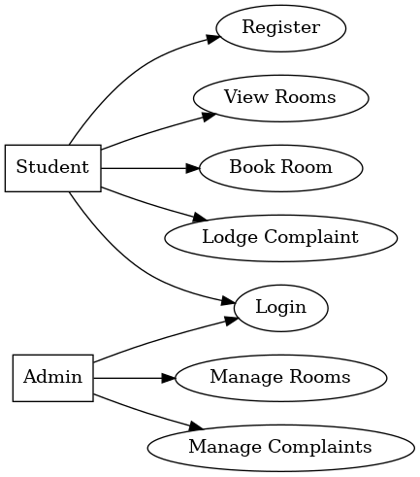

Data Flow Diagram (DFD):

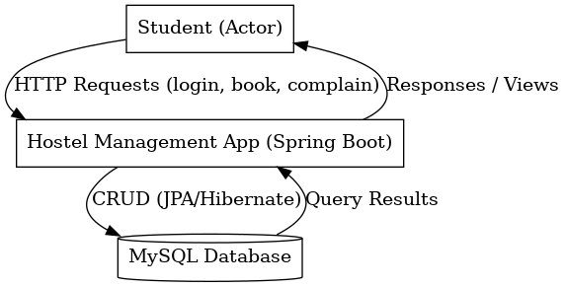

Implementation Details
The Hostel Management System was implemented using Java Spring Boot, Spring Data JPA (Hibernate), and MySQL/H2 as the database. The implementation phase focused on converting the system design and requirements into a working, deployable software application. The project was structured according to best practices for Spring Boot applications, ensuring modularity, readability, and maintainability.
Project Structure
The project follows the standard Spring Boot layered architecture, divided into several key packages and components:
src/
├── main/
│ ├── java/com/hostelmanagement/
│ │ ├── controller/ → REST controllers handling HTTP requests
│ │ ├── model/ → Entity classes representing database tables
│ │ ├── repository/ → JPA repository interfaces for database operations
│ │ ├── service/ → Business logic and service classes
│ │ ├── config/ → Configuration classes (security, CORS, DB setup)
│ │ └── HostelManagementApplication.java → Main entry point
│ └── resources/
│ ├── application.properties → Application configuration and DB settings
│ ├── static/ → Static resources (if frontend integrated)
│ └── templates/ → HTML templates (optional)
└── test/
├── java/com/hostelmanagement/ → Unit and integration test cases
Notable Components and Files
- Main Application Class (HostelManagementApplication.java)
This is the entry point of the application, annotated with @SpringBootApplication, which triggers component scanning, auto-configuration, and dependency injection.
- Model Layer (model/)
Contains entity classes such as Student, Room, Booking, and Complaint.
These classes are annotated with JPA annotations (@Entity, @Id, @GeneratedValue, etc.) and mapped to relational database tables.
Example:
@Entity
public class Room {
@Id
@GeneratedValue(strategy = GenerationType.IDENTITY)
private Long id;
private String roomNumber;
private String type;
private int capacity;
private boolean occupied;
}
- Repository Layer (repository/)
Uses Spring Data JPA to abstract and simplify CRUD operations. Each repository extends JpaRepository, allowing built-in methods like findAll(), save(), deleteById(), etc.
Example:
public interface RoomRepository extends JpaRepository<Room, Long> {
List<Room> findByOccupied(boolean occupied);
}
- Service Layer (service/)
Contains the core business logic and acts as a bridge between the controller and repository layers.
Example:
@ Service
public class BookingService {
@Autowired
private BookingRepository bookingRepository;

public Booking createBooking(Booking booking) {
return bookingRepository.save(booking);
}
}
- Controller Layer (controller/)
Defines RESTful API endpoints using @RestController and @RequestMapping annotations. These controllers handle HTTP requests from the client and return responses in JSON format.

Example:
@RestController
@RequestMapping(\"/api/rooms\")
public class RoomController {
@Autowired
private RoomService roomService;

@GetMapping
public List<Room> getAllRooms() {
return roomService.getAllRooms();
}
}
- Configuration Layer (config/)
Includes application-level configurations such as CORS, database setup, and security rules.
- Resource Folder (resources/)
  - application.properties file defines database connectivity, JPA settings, and console configurations.
  - static/ folder stores front-end resources like CSS, JS, and images (if applicable).
  - templates/ may contain HTML templates if the project uses Thymeleaf or similar engines.

Sample application.properties Configuration
spring.application.name=hostel

# H2 Database Configuration (for testing)
spring.datasource.url=jdbc:h2:mem:hosteldb
spring.datasource.driverClassName=org.h2.Driver
spring.datasource.username=sa
spring.datasource.password=

# JPA/Hibernate Configuration
spring.jpa.database-platform=org.hibernate.dialect.H2Dialect
spring.jpa.hibernate.ddl-auto=create-drop
spring.jpa.show-sql=true

# H2 Console (for debugging)
spring.h2.console.enabled=true
spring.h2.console.path=/h2-console

For production, the H2 in-memory database can be replaced with MySQL using the following configuration:
spring.datasource.url=jdbc:mysql://localhost:3306/hostel_db
spring.datasource.username=root
spring.datasource.password=root123
spring.jpa.hibernate.ddl-auto=update

Application Flow
- The student registers and logs in through the frontend or API.
- Admin adds and manages rooms in the system.
- Students view available rooms and book based on preferences.
- Bookings are stored in the database, ensuring no duplication.
- Complaints are filed and tracked by wardens or admin staff.
- The database is updated automatically through Spring Data JPA transactions.
- The system can be accessed through REST APIs or integrated with a frontend UI.

Testing
Testing was an essential part of the development lifecycle to ensure system correctness, reliability, and performance. Both automated and manual testing approaches were followed.
Testing Strategy
- Unit Testing:
  - Focused on validating individual service and repository components.
  - Used JUnit 5 and Mockito frameworks for creating mock dependencies.
  - Ensured that each method in the service layer performed as expected.
Example:
@SpringBootTest
public class RoomServiceTest {
@Autowired
private RoomService roomService;

@Test
void testCreateRoom() {
Room room = new Room();
room.setRoomNumber(\"A101\");
room.setType(\"Single\");
room.setCapacity(1);
Room savedRoom = roomService.saveRoom(room);
assertNotNull(savedRoom);
}
}
- Integration Testing:
  - Tested communication between components (e.g., controller → service → repository).
  - Verified CRUD operations using an embedded H2 or MySQL test database.
- Manual Testing:
  - Verified real-world use cases such as:
    - Student registration and login.
    - Room creation and booking.
    - Complaint submission and status update.
  - Used Postman to test REST API endpoints manually.
- Database Testing:
  - Confirmed that tables were created correctly using Hibernate.
  - Ensured data consistency after multiple transactions.
- Error and Exception Testing:
  - Tested invalid data submissions, duplicate records, and constraint violations.
  - Ensured proper HTTP responses and user-friendly error messages.

Testing Environments
- Local Development: Using the in-memory H2 database for quick testing.
- Integration Testing: Using a local MySQL instance for realistic data validation.
- Deployment Testing: Verified using Docker containers to ensure portability and consistency.

Screenshots of Outputs
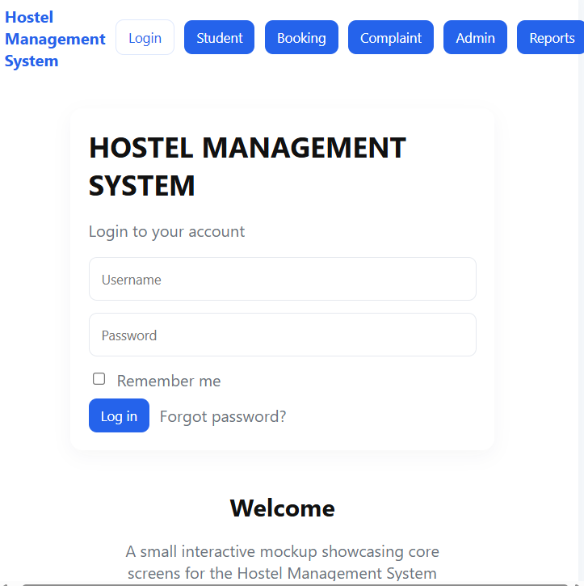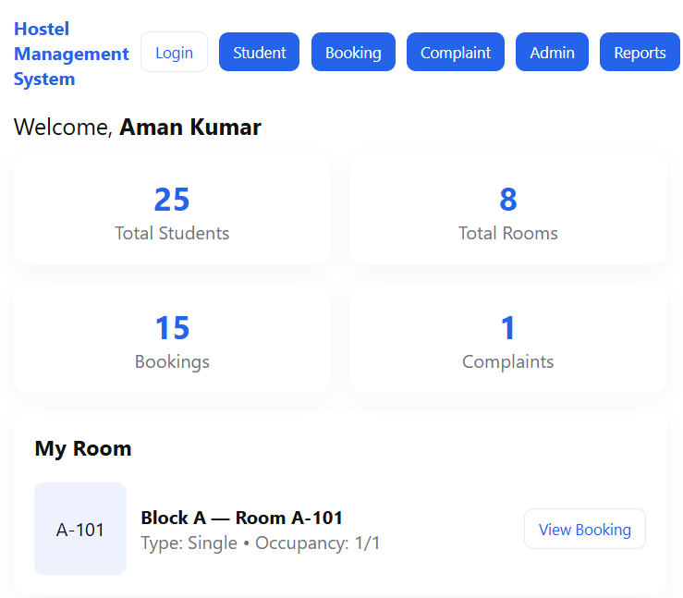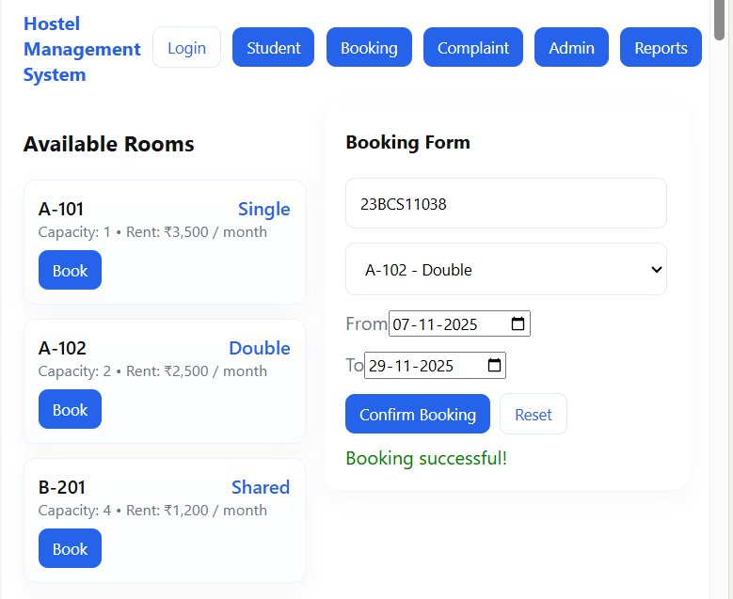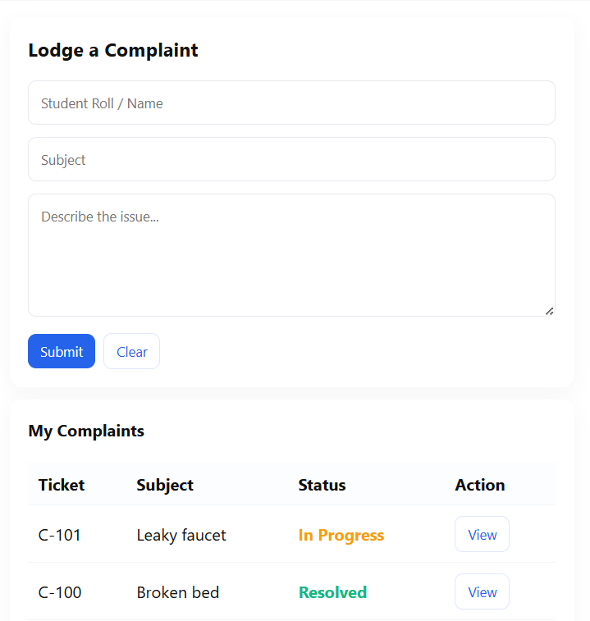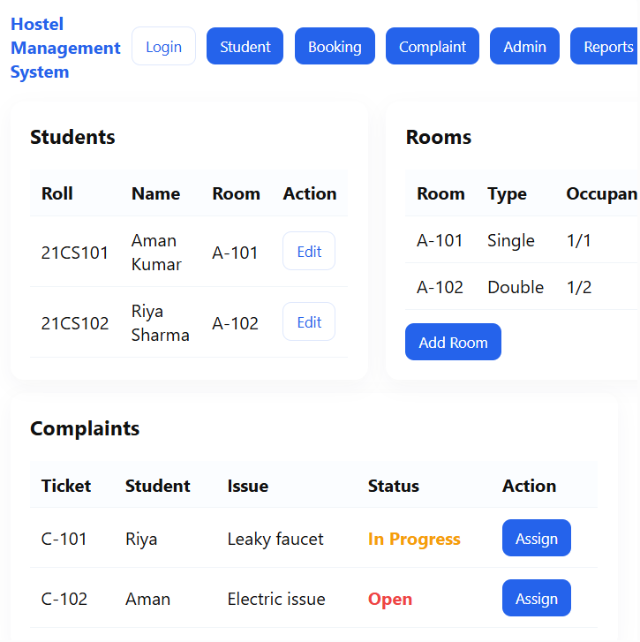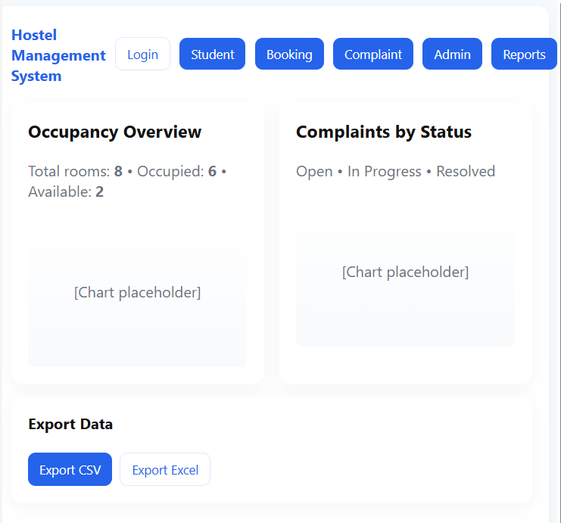
Conclusion & Future Scope
Conclusion
The Hostel Management System successfully demonstrates the practical implementation of modern web technologies to automate hostel operations. It provides an integrated and efficient solution that reduces manual efforts, enhances transparency, and improves operational accuracy.
By using Spring Boot and MySQL, the project achieves a scalable, maintainable, and high-performance backend capable of supporting large datasets and multiple concurrent users. The modular architecture ensures flexibility for further enhancements, and the use of REST APIs makes it easily integrable with various frontend technologies or mobile apps.
The system’s automation features, such as digital record management, online booking, and complaint tracking, contribute to a more organized and responsive hostel environment. The project highlights how technology can modernize traditional management systems while maintaining security, reliability, and user convenience.

Future Scope
• RBAC: Add role-based permissions for Admins, Wardens, Staff, and Students.
• Notifications: Enable email/SMS alerts for bookings and complaints.
• Payments: Integrate online payment gateways (Razorpay/Stripe).
• Responsive UI: Develop a mobile-friendly frontend using React or Angular.
• Analytics: Include dashboards for occupancy and complaint insights.
• Cloud Hosting: Deploy on AWS/Azure for scalability.
• Security: Use JWT authentication and data encryption.
• Mobile App: Build Android/iOS companion apps.
• AI Features: Add room recommendations and demand prediction.
• Database: Optimize queries and add caching for performance.

